The recipe to generating good quality leads and making your battery installer’s life easier

How inbound marketing will send higher quality leads through to the
installer / provider by using the marketing funnel to nurture prospective buyers through an automation that spits out strong leads close to conversion stage.

At the end of 2017, only 12 % of Australian households that had installed solar panels had installed a battery storage system.

State and Federal governments are set to provide renewable energy companies with $2.8bn of subsidies research a year to grow their business and increase the percentage of households using renewables. It’s a great time to be selling solar power batteries!

But here’s the thing. You manufacture /sell great batteries, however you are struggling to lock down good quality leads to hand over to your installer, and close deals.

It is hard to sort those customers who are just browsing from those who are keen to make a purchase, especially if your website and general marketing strategy isn’t set up to keep track of those leads.

With just a few changes to your strategy, you could generate better qualified leads, resulting in happier installers who are not overwhelmed with bad leads.

What you will need:
      - A strong media strategy

Drive customers to your website through:
      - targeted advertising (Facebook, LinkedIn, AdWords),
      - earned media in the print, digital, television and radio space,
      - backlinks to your site.

A well-designed, SEO-optimized website
  - Search engine optimization (SEO). This means someone Googling “solar panel batteries Australia” should hopefully land on a page from your website. If this doesn’t happen, think about optimizing your SEO.
        - Work out which keywords are important to your business through competitor research and market analysis.
        - Change your website’s copy so that it contains these keywords (without overdoing it – Google will penalise you for keyword stuffing!)
        - Consider onboarding an experienced digital marketing agency to help out with the nitty gritty.
  - And what about your website design? How should it look? Well, it should be customer-friendly.
  - Imagine your buyer persona: they own solar panels but are confused about batteries and what exactly they are looking for.
  - We have noticed that the current landscape of Australian battery providers do not have customer-friendly websites. Provide them with the ANSWER they are looking for! They will be grateful, and this will maximise the chances of them getting in touch. Do not overload on complicated information. How could you be helpful?
- Informative content and gated content can be downloaded off your site if the visitor requires further information
  - Usually, a person visiting your website will be in the awareness stage of their buyer’s journey. This means that this lead is experiencing a problem or has questions about their solar energy usage. Your site should not only be trying to sell to those customers, but also inform them.
  - The content on your website needs to be helpful, as it will be a key driver to bringing your leads to the consideration stage of the buyer’s journey.
  - You shouldn’t keep all your content under locks from the website visitor, as this will be frustrating and end up with them leaving.
  - However keeping those extra detailed and useful infographics under the promise of an email address exchange is a powerful conversion strategy!
  - Once the visitor has downloaded that content, you know they are a quality lead, and someone that could potentially end up becoming a buyer.
  - Other ideas are to provide a gated tool that tells potential leads how much they could save using a battery with their solar panels. They won’t believe the results and should hopefully be keen to get in touch immediately!
  - Or include a chat bot or someone from customer service who can answer FAQs.
- A CRM platform to keep a record of contact details for potential customers
  - Finally, the overarching essential for your inbound marketing strategy is your CRM. This is where you will take note of the contact details of all those leads.
  - Using the CRM, will ‘weed’ those leads based on their activity on your site. It is a crucial part of the marketing funnel.
  - A good way to gather more specific information on your leads to make sure they fit your buyer persona is to ask them some questions when they fill out the contact form. Questions such as “Are you already the owner of solar panels?” “Why are you considering purchasing a battery for your home?” “Is this battery for yourself or your business?”
  - Remember: you should never be giving your installer leads who don’t actually want to buy from you, as this is time-wasting.

This sounds like a lot of work, right? Well it can be helpful to let an experienced agency manage all these aspects of your inbound marketing strategy. They have the right tools and knowledge to make sure you are getting those high quality leads and making those sales.

David’s notes:

- State and federal governments are looking to substantially subsidise solar energy in next period

Renewable energy sources such as wind and solar will receive subsidies of up to $2.8 billion a year up to 2030 to ensure Australia reaches its Renewable Energy Target, according to new research. (https://www.afr.com/news/politics/renewable-energy-subsidies-to-top-28b-a-year-up-to-2030-20170313-guwo3t)
"So what are the prospects for a more even playing field? In the case of wind and solar, the subsidy is locked in at least for the next 13 years,"
Downsides of RET:
- Target and cost: the RET is an absolute target in GWhs. Because energy demand projections have been revised downwards, the RET may overreach its 20% goal. Industry groups say this will increase costs.
- Policy uncertainty: the RET scheme has been the subject of regular reviews and numerous legislative changes. This adds investor risk and increases costs. Because the RET legislation does not guarantee connection to the grid, renewable energy developers must negotiate long-term power purchase agreements (PPAs) with electricity retailers. The availability of these PPAs is hampered by policy uncertainty as energy retailers are wary of committing to long-term contracts.
- Interaction with state laws: the RET scheme does not compel state or local governments to facilitate the development of new renewable energy projects. Planning laws are making it increasingly difficult and costly for project developers to find suitable sites.
https://www.aph.gov.au/About_Parliament/Parliamentary_Departments/Parliamentary_Library/pubs/BriefingBook44p/RenewableEnergy

- There are opportunities, but how will customers know you exist? How do you drive traffic to your site, capture those leads, and send the best leads to your sales force or installer?

- AdWords, Facebook ads, earned media to drive traffic to your site Also LinkedIn!

Backlinks

If you are using some paid services to get links to your site, you are likely going to be penalized by Google Penguin’s algorithm.
So here’s the question:
What are some of the ways to get quality backlinks for your blog?
- Write awesome articles
- Use Broken link building method
- Create cornerstone articles (Piller articles)
- Start guest blogging
- Submit to web directories
Earned media

Through promotional efforts. Need ads.
https://www.shoutmeloud.com/backlink.html

How do you make sure leads are qualified?
  - Who is the buyer profile?
  - Interest or intent?
  - Make sure selling to the right person
  - Look at their website??
  - Use a CRM!
https://www.pardot.com/blog/qualify-lead-minute/

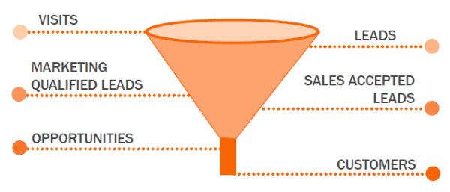

- Want a visitor experience, a clean website – nice visuals, pared back, crisp, clear, engaging text that answers customer questions around value, efficiency, ease – with a call to action to capture customer details so they don’t float off into space, never to be heard from again
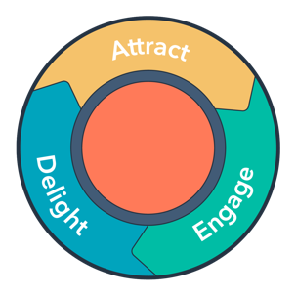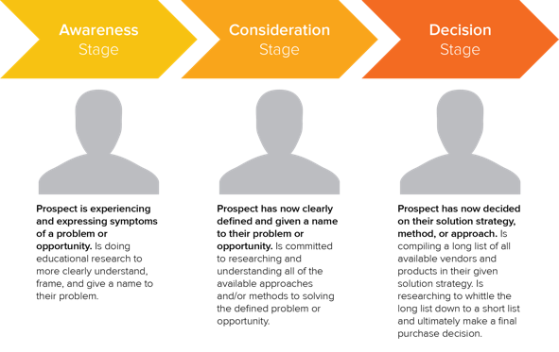

- Data capture – offer a useful piece of content (e.g. how to reduce your power bills by 80% in 28 days) to download in exchange for their contact details
  - To capture leads: could include a tool on the website showing the customer how much they would save if they switched to having a battery. User needs to enter email address to be able to use the tool.
- Most people browsing your site are likely to be in the awareness stage of the buyer’s journey, doing research, so not yet ready to buy. You want to be able to talk to them again. Use inbound marketing automation to re-market with content appropriate to their stage of the buyer’s journey
- A good PR agency can help you find the right people through targeted ads, get you earned media, drive traffic to your site, and once there, show you how to nurture those leads and improve conversions.
- Will the spec work?
- Can this person afford it?
- Are they the decision-maker?
- Permissions that need to be sought?
Getting better qualified leads -> how?
If they don’t want to go ahead, why??

Need a good CRM for the manufacturer.

Your role as the manufacturing company is to provide better qualified leads to your installers to make sure they are not overwhelmed by the number of people that get in touch and are able to focus on those customers that matter.

You are probably aware that the Renewable Energy Targets commenced in 2001, and are due to be in place until 2030, providing renewable energy companies with subsidies (according to research, $2.8bn a year) to grow their business and increase the percentage of the Australian population that uses renewables.

Batteries are one way of saving energy that has been overlooked by a number of households due to cost and lack of understanding. 70% of households who use solar panels do not use a battery to store the energy the panels are gathering during the day. Seems incredibly wasteful? It is time to position your company as the market leader as there are plenty of opportunities.

